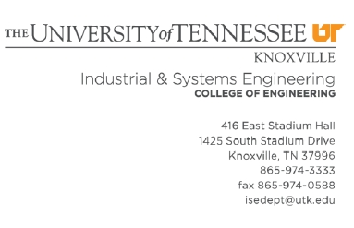

On behalf of the Department of Industrial and Systems Engineering, please receive our warmest
greeting. First of all, we want to thank you for your interest in collaborating with our institution. As a first approach, the Lean Enterprise Systems Summer Program offers an outstanding experience not only academically, but as well culturally for your students. We are confident that this is the beginning of a long journey between the two institutions.

This program represents a very important part of our department’s essence, as we are constantly
striving to share our research and learn from other institutions. In this particular case, the students
will learn about cultural dimension being a major factor used to implement improvement efforts in
industries around the world. For this reason, we consider it important to have space open for
discussion not only with the students attending the program, but also, with the faculty from
Jiangnan University. We believe that your institution has provided the participating students with
that vision to look outside the box and prepare for a very competitive and globalized world.

We want to extend a cordial invitation for you and your students to participate in this program. The program runs from June 30th to July 3rd in a distance education format, which allows students to
participate from their own locations. Then, students have a chance to travel to Knoxville between the 4th and the 6th, to start the in-campus lectures on July 7th. They will be here for four weeks
participating in this program, until August 1st, when they have to present a report for their capstone project developed during this time.

The program has a cost of $3,350 US dlls, and includes the following: • Tuition and fees for the program.
• Materials for the program.
• Lodging at University Residence Halls for the duration of the program (28 nights). • A meal card with $400 US dlls of credit to spend at any food vendor in campus. • Fieldtrips to companies.
• Transportation to capstone project organizations. • Some cultural trips.
• One professor’s lodging and $400 US dlls for every 15 participants from the same institution.

NOTE: Some institutions in other countries charge students an additional fee per student for
operational costs (airfare, money transfer fees, paperwork, etc.). This is only a suggestion and the
program administration does not mandate or oblige your institution to make this extra charge.

The requirements of participation for students are: • Engineering and Business major.
• Academic good standing.
• Proof of proficiency in the English language (can be arranged through interviews if there is no test
score available)

The program does not include:
• Airfare from your country to US.
• VISA paperwork expenditures.
• International insurance (it is mandatory to have insurance to come to this program). An option to
buy is Travel Guard (http://www.travelguard.com/travelinsurance/international.asp)
• Personal expenditures such as leisure trips, food outside campus, clothing, etc.

Important deadlines are May 23th for the definitive list of participants in the program (you should
consider to determine an earlier internal deadline, we recommend May 2nd, and the payment for the program in one installment by your institution in June, upon notification for the precise date once the final enrollment list is turned in.
We will appreciate if you could arrange to provide the program information to your students, and as well, we want to make ourselves available for any further information required, which will be
provided promptly.
Thank you again for your interest and we look forward to having your students here this summer at the University of Tennessee.

